**Stevenage Central Library Visual Story**

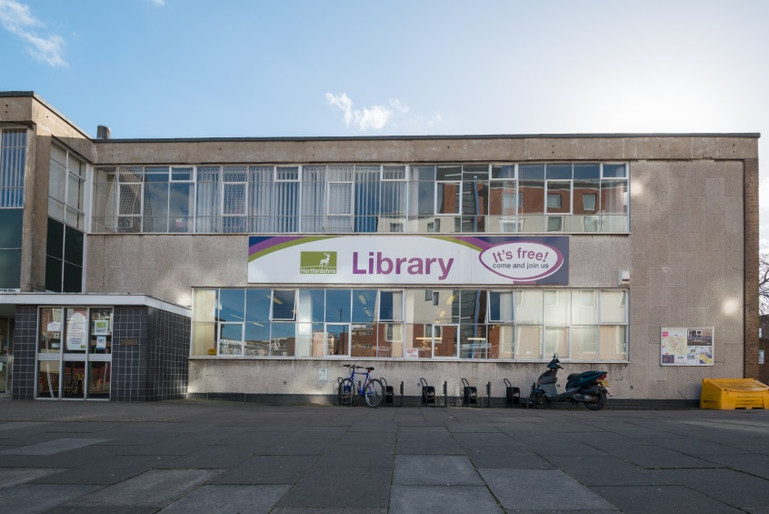

**Stevenage Central Library, Southgate,**

**Stevenage, SG1 1HD**

**Opening Hours:**

|  |  |  |  |
| --- | --- | --- | --- |
| Monday | 10.00am | - | 7.00pm |
| Tuesday | 10.00am | - | 6.00pm |
| Wednesday | 10.00am | - | 6.00pm |
| Thursday | 10.00am | - | 6.00pm |
| Friday | 10.00am | - | 6.00pm |
| Saturday | 10.00am | - | 5.00pm |
| Sunday | 12.00pm | - | 4.00pm |

This is a simple guide to help people visiting Stevenage Central Library for the first time. If you have any questions, please ask the staff.

|  |  |
| --- | --- |
| outside view of front of building with a large sign saying library n the middle of the wall | This is the Stevenage Central Library   |
| large desk with someone sitting behind a computer. there are leaflets and posters behind the desk and a sign above saying enquiries | This is the help desk. Ask here if you need help or have any questions.    If it is busy, you may need to queue. |
| a man smiling at the camera showing his staff badge | Library staff are here to help. All library staff wear a badge like this.   |
| **library cards** | This is a library card. You will get one when you become a library member. Children aged 5 and under get their own ‘My First’ card.    You need a library card to borrow books and to use the computers.  To get a library card, ask the staff at the help desk. |
| **headphones** | Sometimes we have noisy times in the library and you may wish to visit at a quieter time.    Or you can bring some ear defenders to wear. |
| pink self service kiosk with metal book trolley next to it | This is a kiosk. You can borrow and return books here.    Follow the instructions on the screen. Ask the library staff if you need help.  If it is busy, you may need to queue. |
| at the front on the floor are boxes with picture books. there are shelves with books either side along the room**large open area with children's tables and chairs on the left and book shelves at hte back and right** |     This is the children’s area.     |
| rows of shelves with books  shelves with magazines on display | There are lots of books you can borrow.    You can also borrow magazines.   |
| lift doors | This is the lift which will take you up to the first floor.   |
| part-open white door with a toilet sign on it | There is a toilet in the library.    If it is busy, you may need to queue. |
| **rows of computers on long desk** | These are the computers. Library members can use them for free for two hours each day.    If the computers are busy, you may need to book.  Ask the library staff if you need help. |
| **tables with chairs and shelves with books on the back wall** | This is the quiet study area. There is free Wi-Fi in the library.   wifi logo  Ask staff for login details. |
| hand holding a library card at a self service kiosk | When you are ready to leave the library, take the things that you want to borrow to the kiosk and follow the instructions on the screen. Ask the library staff if you need help.    If it is busy, you may need to queue. |
| cid:4c311b1f-8343-42b0-8ecf-9e181c4cca5d@Hertfordshire.gov.uk | You can take the things you have borrowed home. Print a receipt so you know when you need to bring them back to the library.    If you need some help, just ask a member of staff. |
| cid:38b11f0d-3e1d-4975-99eb-d73f8a421c04@Hertfordshire.gov.uk | We hope you enjoyed the story.  If you need any extra help or information, please ask a member of staff.     For more information on the library please visit our website:  [www.hertfordshire.gov.uk/stevenagecentrallibrary](https://www.hertfordshire.gov.uk/stevenagecentrallibrary)  Please come back soon. ☺ |