St Albans Library Visual Story
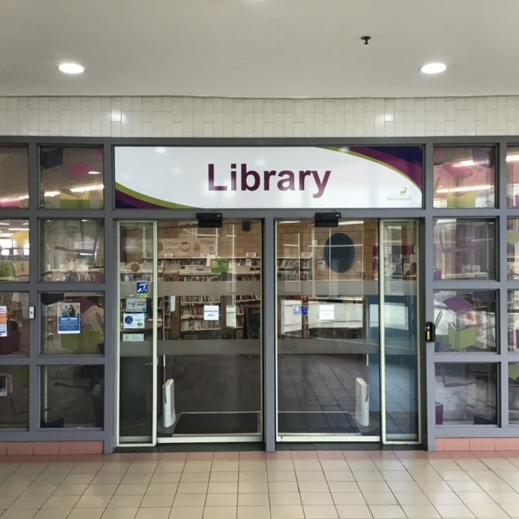
St Albans Central Library, Second floor of The Maltings, St Albans, AL1 3JQ

www.hertfordshire.gov.uk/libraries

Opening Hours:
Monday | 10.00am - | 6.00pm
Tuesday | 10.00am - | 7.00pm
Wednesday | 10.00am ⁻ | 6.00pm
Thursday | 10.00am - | 6.00pm
Friday | 10.00am - | 6.00pm
Saturday | 10.00am - | 5.00pm
Sunday | 12.00pm - | 4.00pm

This is a simple guide to help people visiting St Albans Central Library for the first time, if you have any questions, please ask the staff.

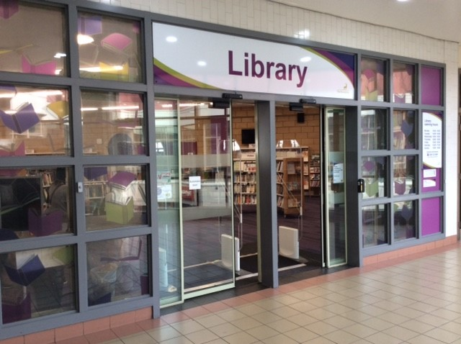 | This is St Albans Library.  
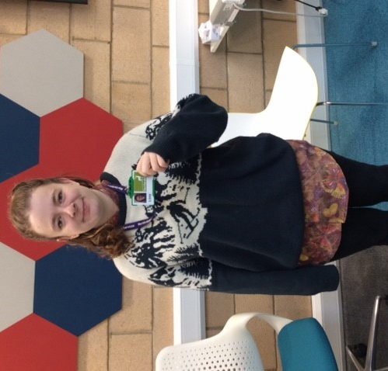 | Library staff are here to help. All library staff wear a badge like this.  

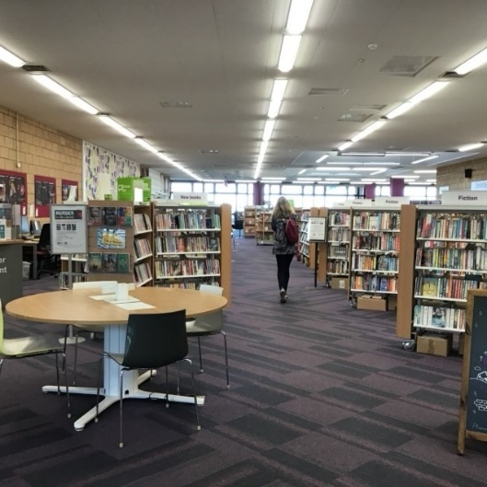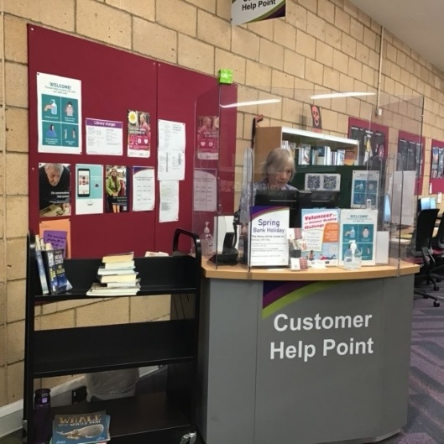 | This is the help point. You will see this when you enter the library. Library staff are here to help you in the library.  
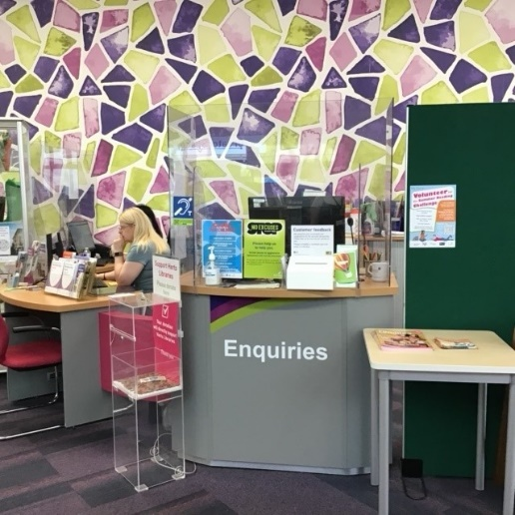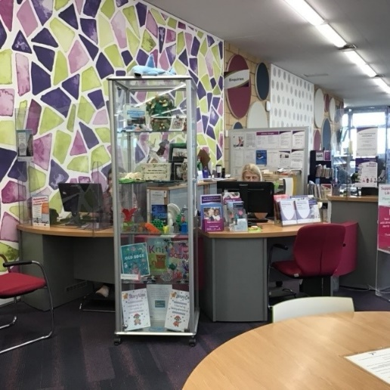 | This is the help desk. Ask here if you need help or have any questions.    If it is busy you may need to queue.
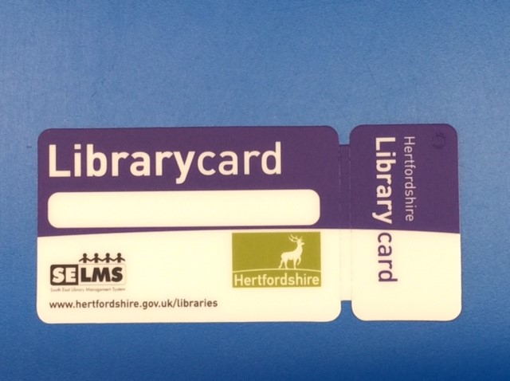 | This is a library card; you will get one when you become a library member.    You need a library card to borrow books, talking books and to use the computer.
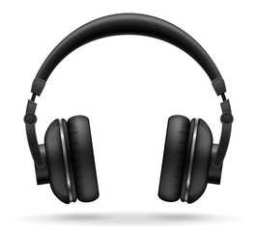 | At some times the library can be noisy, and you may wish to visit at a quieter time.    Or you can bring ear defenders to wear.

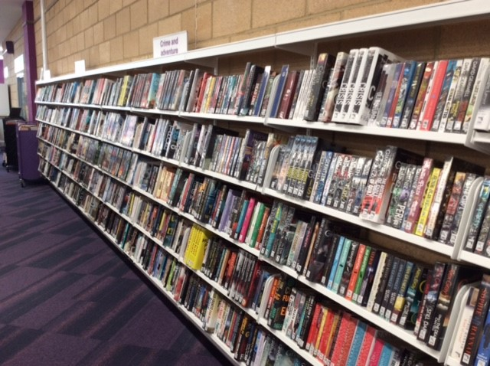 | There are plenty of books you can borrow.  
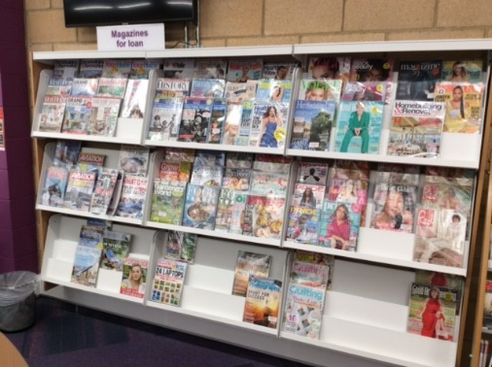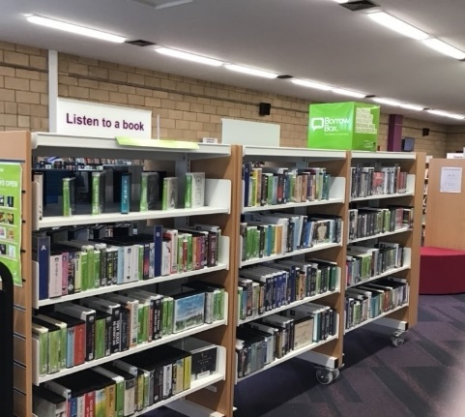 | You can also borrow magazines and talking books.  

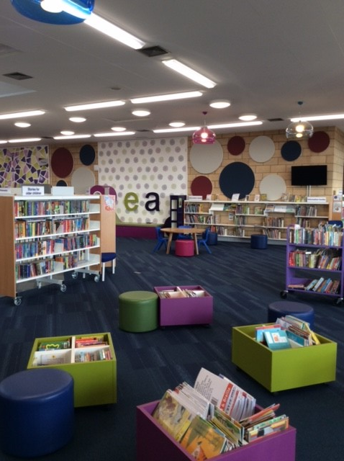 | This is the children’s area.  
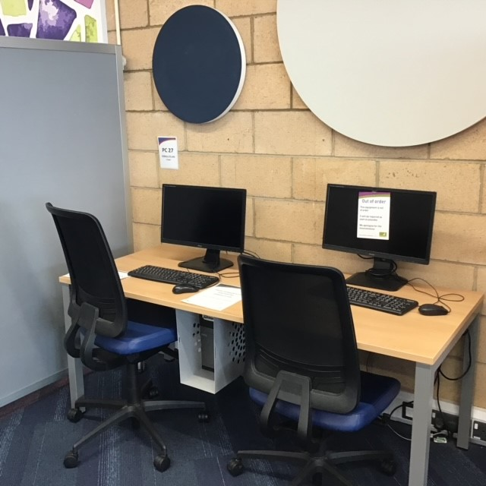 | The computers near the children’s area are just for children to use.  

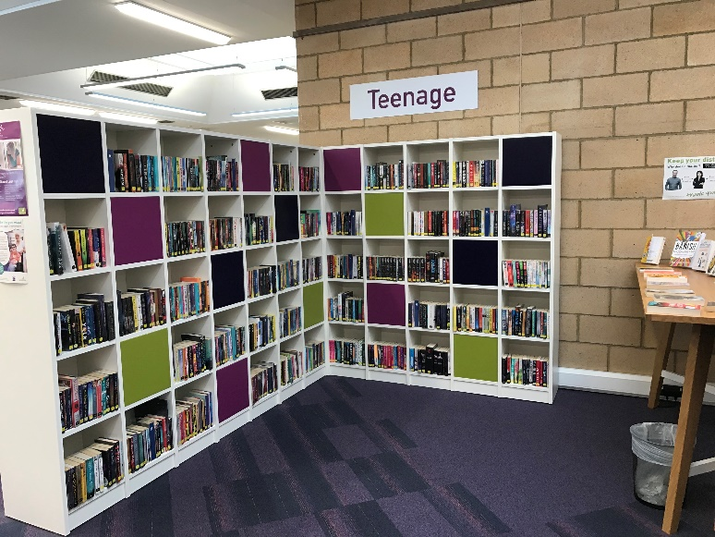 | This is the teenage section.  
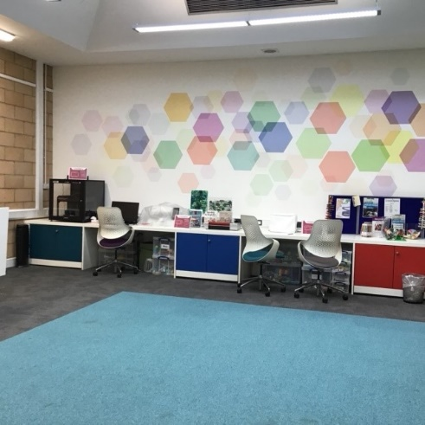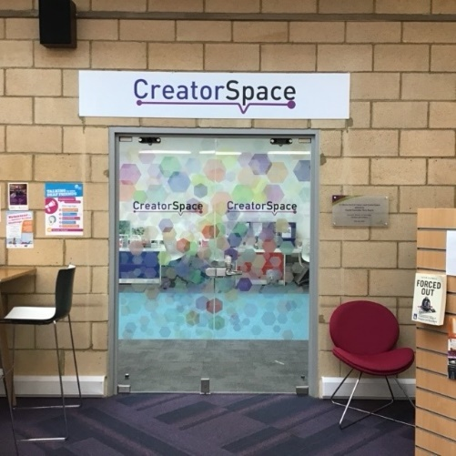 | This the CreatorSpace section. This room has lots of equipment, such as a 3D printer, sewing machine and film equipment. These items can be hired for a fee, ask the staff for more information.  
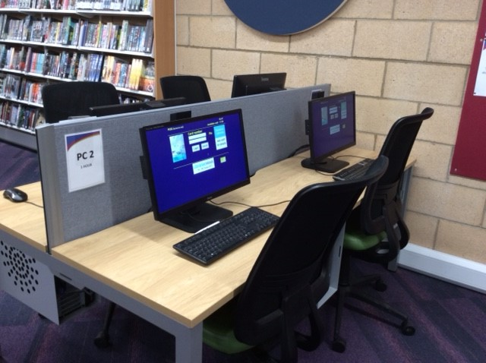 | These are the computers. Library members can use them for free for two hours a day.    If the computers are busy you may need to book. Ask the staff if you need help.
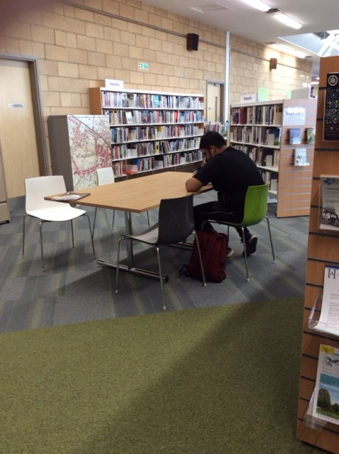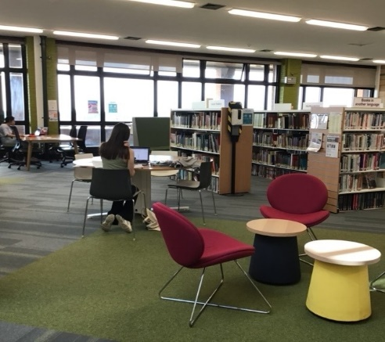 | These are quiet study areas and non-fiction books.    There is free Wi-Fi in the library. Ask staff for login details.  There is also a photocopier and scanners.
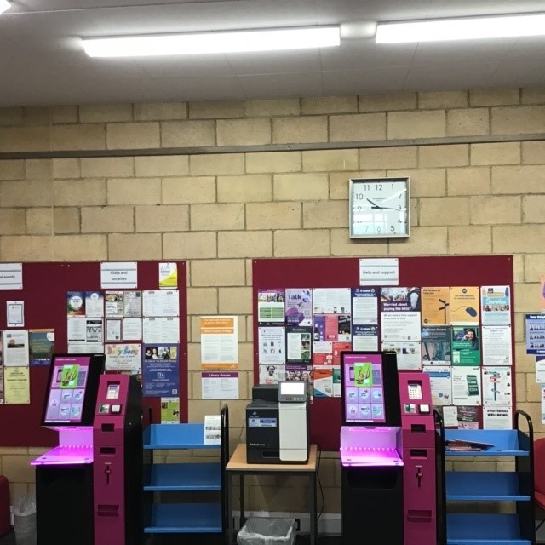 | These are the kiosks. You can borrow and return books here.    Follow the instructions on screen. Ask the library staff if you need help. If it is busy you may need to queue.
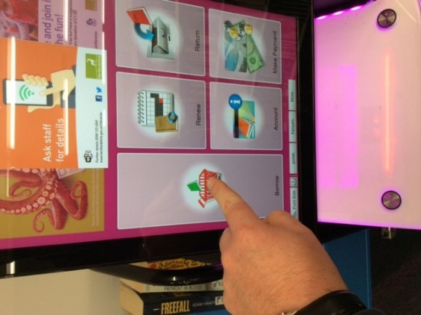 | When you are ready to leave the library take the things that you want to borrow to the kiosk and follow the instructions on screen. Ask the library staff if you need help.  
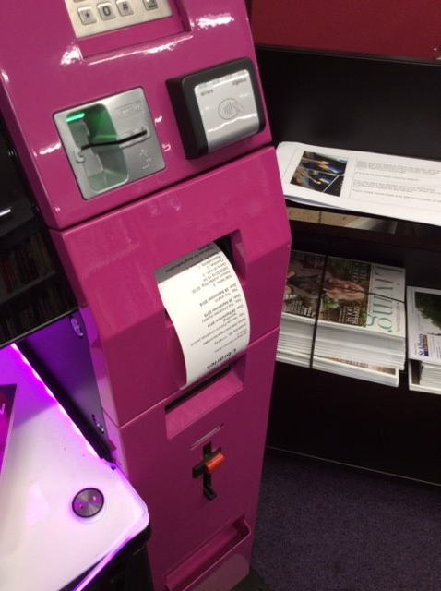 | You can take the things you have borrowed home. Print a receipt so you know when you need to bring them back to the library.    If you need some help, ask a member of staff.
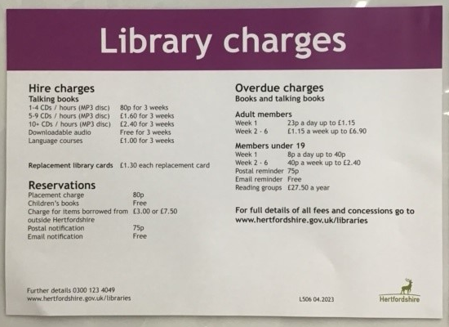 | We charge for some library services. Please ask staff for more information of all charges.  
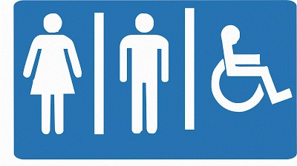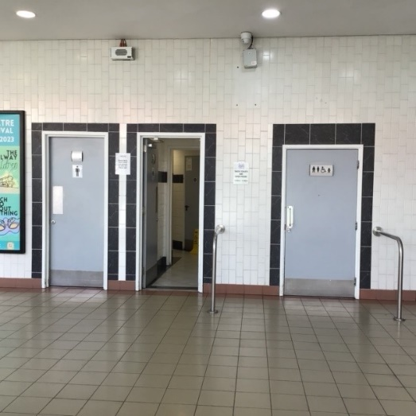 | There are toilets in the Maltings shopping centre just outside the library’s front door.  
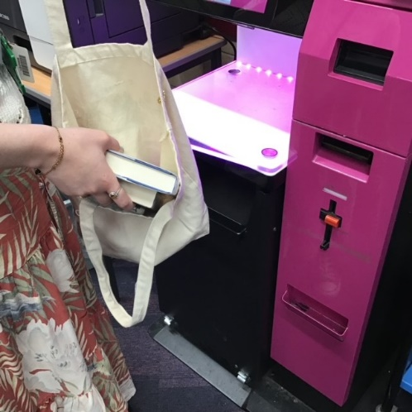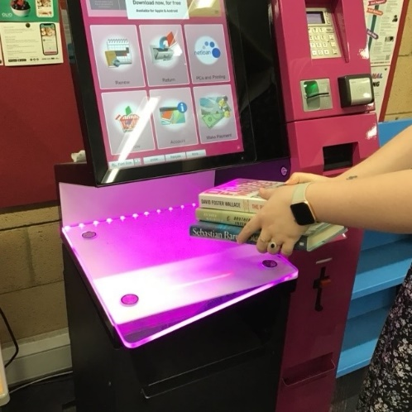 | We hope you enjoyed the story.   If you need any extra help or information, please ask a member of staff  For more information on the library please visit our website:  www.hertfordshire.gov.uk/stalbanslibrary  Please come back soon. ☺

