**Hoddesdon Library Visual Story**

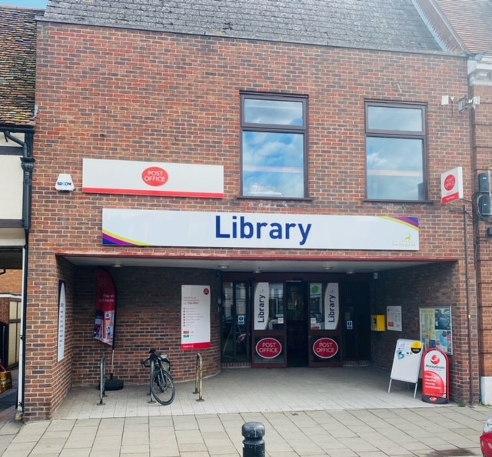

**Hoddesdon Library, 98a High Street, Hoddesdon, EN11 8HD**

**Opening Hours:**

|  |  |  |  |
| --- | --- | --- | --- |
| **Monday** |  9.00am | - |  6.00pm |
| **Tuesday** |  9.00am | - |  6.00pm |
| **Wednesday** |  9.00am | - |  7.00pm |
| **Thursday** |  9.00am | - |  5.30pm |
| **Friday** |  9.00am | - |  6.00pm |
| **Saturday** |  9.00am | - |   4.00pm |
| **Sunday** | Closed |  |  |

This is a basic guide to assist people visiting Hoddesdon Library for the first time, if you have any questions, please ask the staff.

|  |  |
| --- | --- |
| front of brick building with sign above door saying library | This is Hoddesdon Library.  We do not have steps leading into the main floor of the library, so it is suitable for anyone with mobility issues.   |
| **two desks with computers. someone is sitting at a computer** | This is the enquiry desk. Ask here if you need help or have any questions.  If it is busy you may need to queue.   |

|  |  |
| --- | --- |
| **A man standing in a library with a staff badge** | Library staff are here to help.  All library staff wear a badge like this.   |
| **headphones** | Sometimes we have noisy times in the library and you may wish to visit at a quieter time.    Or you can bring with you some ear defenders to wear. |

|  |  |
| --- | --- |
| **library cards front and back** | This is a library card, you will get one when you become a library member.    We have adult library cards and special library cards for children, and you will receive one of these when you become a library member.  You will need a library card to borrow books audio discs and to use the computers.  To get a library card, ask the staff at the help desk. |
| **woman standing by the self service kioskself service kiosk with a book**  pink self service kiosk | This are our self-service kiosks. Your library card will also give you access to use these so you can borrow and return books. Staff are available to assist you with using the kiosks if needed. Print a receipt so you know when to return your books.    If it is busy you may need to queue. |
| **large inside space with book shelves on the wall and wooden boxes full of picture books on the floor** | This is the children’s area.    As you can see, there are lots of books for them to read and borrow. We also use this area for our Baby Rhyme Time sessions and Storytime sessions. As well as lots of other events. |
| **A bookshelf with many booksshelves with booksshelves with magazines on display** |   We also have a huge selection of books, magazines, and audio disks to borrow. |
| **Post Office counter with person sitting behind desk** | Hoddesdon Library is lucky enough to have a Post Office on site. It is open Monday-Friday 9.00-5.00 and 9.00-12.30 on a Saturday.   |
| **white door with large metal handle** | We also have a lift to access the lower ground floor and to help those with mobility issues.   |
| toilet sign with stylised pictures of a woman, a man, and a person in a wheelchair | There is a toilet in the library.  If it is busy you may need to queue. |
| **area with computer desks, screens and chairs** | These are the computers in the main part of the library. Library members can use them for free for one hour a day.  If the computers are busy you may need to book. Ask the library staff if you need help.   |

|  |  |
| --- | --- |
| **A room with tables and chairs**  **a wooden door with a sign of a person in a wheelchairlarge area with computer desks and chairs** | We also have more computers downstairs in our quiet study area. We have plenty of space for studying here.  There is free Wi-Fi in the library. wifi logo  There is also a public toilet on this floor.   |
| **long and narrow room with tables and chairs** | This is our meeting and activity room. It is available for hire. Please ask a member of staff for more details**.**   |
| cid:e43681d1-e20f-4615-8f86-7795d43b3938@Hertfordshire.gov.uk | When you are ready to leave the library, take the things that you want to borrow to the kiosk and follow the instructions on the screen. Ask the library staff if you need help.  If it is busy you may need to queue.   |
| cid:4c311b1f-8343-42b0-8ecf-9e181c4cca5d@Hertfordshire.gov.uk | You can take the things you have borrowed home. Print a receipt so you know when you need to bring them back to the library.    Remember to return or renew your items on time to avoid charges.  You can renew your items at the kiosk or:   * ask at the desk * online at [www.hertfordshire.gov.uk/libraries](http://www.hertfordshire.gov.uk/libraries) * Telephone: 0300 123 4049 * Textphone: 0300 123 4041 |
| cid:38b11f0d-3e1d-4975-99eb-d73f8a421c04@Hertfordshire.gov.uk | We hope you enjoyed the story.  If you need any extra help or information please ask a member of staff.     For more information on the library please visit our website:  [www.hertfordshire.gov.uk/hoddesdonlibrary](https://www.hertfordshire.gov.uk/hoddesdonlibrary)  Please come back soon. ☺ |