**Hemel Hempstead Library Visual Story**

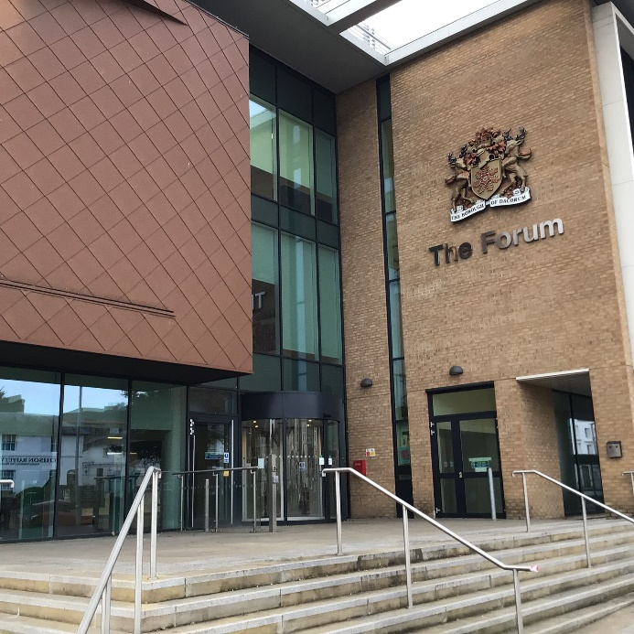

**Hemel Hempstead Library, The Forum, Marlowes, Hemel Hempstead, HP1 1DN**

|  |  |
| --- | --- |
| www.hertfordshire.gov.uk/libraries | **HCC Logo GREEN (2019-02)** |

**Opening Hours:**

|  |  |  |  |
| --- | --- | --- | --- |
| Monday | 9.00am | - | 6.00pm |
| Tuesday  ***Self-service***  ***Full service*** | 9.00am  12.00pm | -  - | 12.00pm  6.00pm |
| Wednesday | 9.00am | - | 6.00pm |
| Thursday | 9.00am | - | 7.00pm |
| Friday | 9.00am | - | 6.00pm |
| Saturday | 9.30am | - | 4.00pm |
| Sunday | 12.00pm | - | 4.00pm |

This is a simple guide to help people visiting Hemel Hempstead Library for the first time, if you have any questions please ask the staff.

|  |  |
| --- | --- |
| one desk with computer with seating area and bookshelves in the background | This is Hemel Hempstead Library    We opened in January 2017 in the Forum. We have a bright open space, and plenty of books to borrow, chairs to sit on and computers to use. |
| large seating area with low table and blue chairs  2 women by display unit smiling at the camera and wearing staff badges | You can borrow books outside the library when it is both open and closed.    There is also a café outside the library.  If you need help please ask a member of staff, they will be wearing badges like these.    The people who work here are all friendly and will be pleased to help you. |
| library cards front and back | This is a library card, you will get one when you become a library member.    You need a library card to borrow books and to use the computers.  To get a library card, ask the staff at the help desk. |
| **headphones** | Sometimes we have noisy times in the library and you may wish to visit at a quieter time.    Or you can bring some ear defenders to wear. |
| touchscreen self service kiosk | This is a kiosk. You can borrow and return books here.    Follow the instructions on the screen. Ask the library staff if you need help.  If it is busy you may need to queue. |
| receipt coming out of self service kiosk | The kiosk will give you a receipt to remind you what you have borrowed or returned.    Remember to return or renew your items on time to avoid charges.  You can renew your items at the kiosk or:   * ask at the desk * online at [www.hertfordshire.gov.uk/libraries](http://www.hertfordshire.gov.uk/libraries) * Telephone: 0300 123 4049   Textphone: 0300 123 4041 |
| furniture to display books spelling the word story with the letter o open for seating | This is the children’s area. There is plenty of space and it is very colourful.   |
| comfortable seating area with shelves of books in the background | There are lots of books you can borrow. There are lots of other items you can borrow or just look at.   |
| study spaces with computers, split in two areas by short partition | We have lots of computers for you to use.    Library members can use them for free. |
| desk with public computer | If the computers are busy you may need to book. Ask the library staff if you need help.   wifi logo  There is free Wi-Fi in the library.  Ask staff for login details. |
| desk with computer and 3D printer | We have a area called CreatorSpace where you can use equipment like a 3D printer and Apple Mac computers.    You need to pay to use this equipment. |
| long table with chairs in meeting room | We also have a meeting room.   |
| toilet sign with male, female, baby change and wheelchair symbol | We have a toilet which needs a special key to open it.    If you need to use this toilet ask a member of staff. |
| help desk with perspex screens | We hope you enjoyed the story.  If you need any extra help or information please ask a member of staff.     For more information on the library please visit our website:  [www.hertfordshire.gov.uk/hemelhempsteadlibrary](https://www.hertfordshire.gov.uk/hemelhempsteadlibrary)  Please come back soon. ☺ |