**Hatfield Library Visual Story**

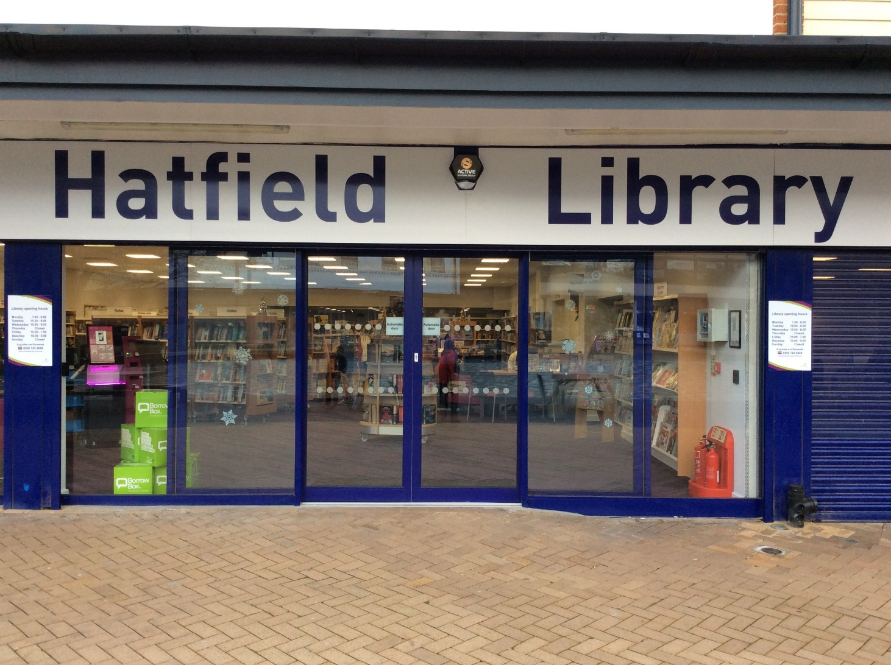

**Hatfield Library, 26-32 Town Centre, Hatfield, AL10 0LD**

**Opening Hours:**

|  |  |  |  |
| --- | --- | --- | --- |
| Monday | •1.00pm | - | 6.00pm |
| Tuesday | 10.00am | - | 6.00pm |
| Wednesday | 10.00am | - | 6.00pm |
| Thursday | Closed |  |  |
| Friday | 10.00am | - | 🕖7.00pm |
| Saturday | 10.00am | - | 5.00pm |
| Sunday | Closed |  |  |

This is a simple guide to help people visiting Hatfield Library for the first time, if you have any questions please ask the staff.

|  |  |
| --- | --- |
| **glass front doors with signs saying Hatfield Library on top** | This is Hatfield library   |
| **2 chairs in front of desk. A man is sitting behind the desk looking at a computer screen** | This is the help desk. Ask here if you need help or have any questions.    If it is busy you may need to queue. |
| a woman smiling showing her staff badge | Library staff are here to help. All library staff wear a badge like this.   |

|  |  |
| --- | --- |
| **headphones** | Sometimes we have noisy times in the library and you may wish to visit at a quieter time.    Or you can bring some ear defenders to wear. |

|  |  |
| --- | --- |
| front of a library cardback of a library card | This is a library card. You will get one when you become a library member.    You need a library card to borrow books and to use the computers.  To get a library card, ask the staff at the help desk. |
| **pink self service kiosk** | This is a kiosk. You can borrow and return books here.    Follow the instructions on the screen. Ask the library staff if you need help.  If it is busy you may need to queue. |
| **A book shelf filled with books** | There are lots of books you can borrow and take home with you. You need to bring them back to the library after.    Or you can sit in the library and read them. |
| Three books on a table, one about pyramids, one about birds and one about cars. | There are fact books about lots of different things.    Ask the library staff for help and we can find you a book about something you like. |
| Open pages of picture books for adults with learning disabilities. | We have books with lots of pictures that are easy to read. They are called **Books for Everyone.**   |
| shelves with magazines on display | We also have magazines.    You can take them home with you. You will need to bring them back to the library after.  Or you can sit in the library and read them. |
| A desktop computer sitting on a table | These are the computers. All library members can use them for free for two hours a day.    If the computers are busy you may need to book. Ask the library staff if you need help. |
| a wooden door | There is a toilet in the library.    If it is busy you may need to queue. |
| **room with book shelves in the back, a colourful carpet. At the front is a sofa with a wooden box full of picture books next to it** | This is the children’s area.    There are lots of books you can take home with you.  Or you can read them in the library. |
| Photo of a story book with Makaton signs. | There are some books with Makaton.    We can help you find these books if you need help. |
| wooden box with large picture booksbook open showing very large print on the left page and an picture of birds on the right page | There are books with big letters and braille.    We can help you find these books if you need help. |
| shelves of books | This is the teenage area.    There are lots of different books, including teenage graphic novels. |

|  |  |
| --- | --- |
| shelves of books in a corner with large volumes and a sign saying local historyentrance of a large room wit a sign above saying local studies. In the room are filing cabinets, a table and chairs | This area is called Local Studies. There are lots of old photos and maps of our town.    Ask the staff if you want to look at these. We might even be able to show you what your house used to look like. |
| entrance to a large room with modern table and chairs. It says CreatorSpace on the doorround table with chairs at the front and comfortable seating in the backgroundlarge room with white cupboards in the background, 2 round tables with chairs around and comfortable seating in the back | This area is called the CreatorSpace. We have some computers and places to sit in here. We also have a photocopier you can use.    Sometimes we hold events in here. These might be noisy. If there is an event happening in the CreatorSpace, you can still use the rest of the library. |
| **charges and concessions leaflet** | Some of our services you have to pay for.  Please ask staff for more information.    |
| comfortable seating by a window with small table in the middle | If you need a quiet area please ask staff for assistance. There is free Wi-Fi in the library.   wifi logo  Ask staff for login details. |
| a woman is putting books in a self service kiosk | When you are ready to leave the library, take the things that you want to borrow to the kiosk and follow the instructions on the screen. Ask the library staff if you need help.    If it is busy you may need to queue. |
| woman taking a receipt from self service kiosk | You can take the things you have borrowed home. Print a receipt so you know when you need to bring them back to the library.  Remember to return or renew your items on time. You might have to pay some money if you bring them back late.  You can renew your items at the kiosk or:   * ask at the desk * online at [www.hertfordshire.gov.uk/libraries](http://www.hertfordshire.gov.uk/libraries) * Telephone: 0300 123 4049 * Textphone: 0300 123 4041 |
| woman putting books in a plastic bag next to self service kiosk | We hope you enjoyed the story.  If you need any extra help or information please ask a member of staff.     For more information on the library please visit our website:  [www.hertfordshire.gov.uk/hatfieldlibrary](https://www.hertfordshire.gov.uk/hatfieldlibrary)  Please come back soon. ☺ |