**Radlett Library Visual Story**

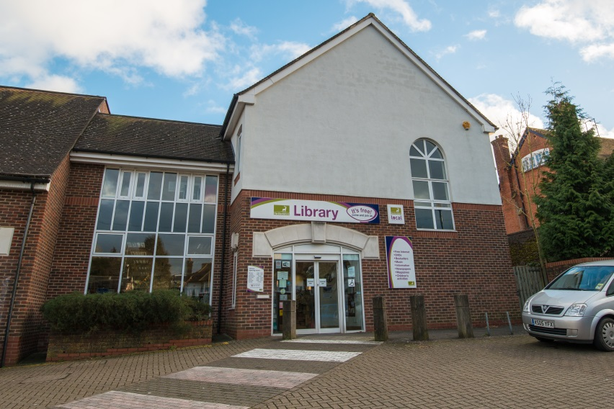

**Radlett Library, 1 Aldenham Avenue, Radlett, WD7 8HL**

**Opening Hours:**

|  |  |
| --- | --- |
| **Monday** | •1.00pm - 6.00pm |
| **Tuesday** | 10.00am - 6.00pm |
| **Wednesday** | Closed |
| **Thursday** | 10.00am - 6.00pm |
| **Friday** | 10.00am - 6.00pm |
| **Saturday** | 10.00am - 2.00pm |
| **Sunday** | Closed |

This is a simple guide to help people visiting Radlett Library for the first time, if you have any questions, please ask the staff.

|  |  |
| --- | --- |
| outside view of front of brick building with large sign above doors saying Library | This is Radlett Library   |
| **large desk with computer screen and cupboards in the background** | This is the help desk. It is downstairs.    Ask here if you need help or have any questions.  If it is busy you may need to queue. But we will do our best to assist as quickly as possible |

|  |  |
| --- | --- |
| a woman smiling showing her staff badge | Library staff are here to help.  All library staff wear a badge like this.   |
| **headphones** | Sometimes we have noisy times in the library and you may wish to visit at a quieter time.    Or you can bring with you some ear defenders to wear. |

|  |  |
| --- | --- |
| cid:f84901bb-bfbf-4603-adb8-67b20b990467@Hertfordshire.gov.uk | This is a library card, you will get one when you become a library member.    You need a library card to borrow books and to use the computers.  To get a library card, ask the staff at the help desk. |
| **large open area with bookshelves and self service kiosk in the middle** | This is a kiosk. You can borrow and return books here.    Follow the instructions on the screen. Ask the library staff if you need help.  If it is busy you may need to queue. |
| **inside area with bookshelves and a sofa on the left, bookshelves at the back and wooden boxes of picture books in the middle** | This is the children’s area downstairs. We have some lovely colourful stools and a very comfy new sofa for kids to sit and enjoy reading our large collection of picture books and junior fiction   |
| **book display unit and shelves with books on the back wall** | There are lots of books you can borrow downstairs.  We have our dedicated Hot Picks display stand as well as a decent large print and audio selection to complement our ever growing collection.   |
| shelves with magazines on display | You can also borrow magazines, we have a wide variety including country life, fitness, fashion, history and technology.   |
| toilet sign with stylised pictures of a woman, a man, a person changing a baby and a person in a wheelchair | There is a toilet in the library. The toilet is upstairs.    If it is busy you may need to queue. |
| desks with computer screens and 2 chairs | These are the computers. They are downstairs. Library members can use them for free for one hour a day.    If the computers are busy you may need to book.  Ask the library staff if you need help. |
| lift doors | Radlett Library has an upstairs and a downstairs.    You can use the lift or the stairs. |
| stairs | These are the stairs to go upstairs or downstairs.    Ask the library staff if you need help. |
| large inside area with tables and chairs | This is the study area. This is upstairs.   wifi logo  There is free Wi-Fi in the library.  Ask staff for login details. |
| cid:e43681d1-e20f-4615-8f86-7795d43b3938@Hertfordshire.gov.uk | When you are ready to leave the library, take the things that you want to borrow to the kiosk and follow the instructions on the screen. Ask the library staff if you need help.  If it is busy you may need to queue.   |

|  |  |
| --- | --- |
| cid:4c311b1f-8343-42b0-8ecf-9e181c4cca5d@Hertfordshire.gov.uk | You can take the things you have borrowed home. Print a receipt so you know when you need to bring them back to the library.    Remember to return or renew your items on time to avoid charges.  You can renew your items at the kiosk or:   * ask at the desk * online at [www.hertfordshire.gov.uk/libraries](http://www.hertfordshire.gov.uk/libraries) * Telephone: 0300 123 4049 * Textphone: 0300 123 4041 |
| cid:38b11f0d-3e1d-4975-99eb-d73f8a421c04@Hertfordshire.gov.uk | We hope you enjoyed the story.  If you need any extra help or information, please ask a member of staff.     For more information on the library please visit our website:  [www.hertfordshire.gov.uk/radlettlibrary](https://www.hertfordshire.gov.uk/radlettlibrary)  Please come back soon. ☺ |