**Oxhey Library Visual Story**

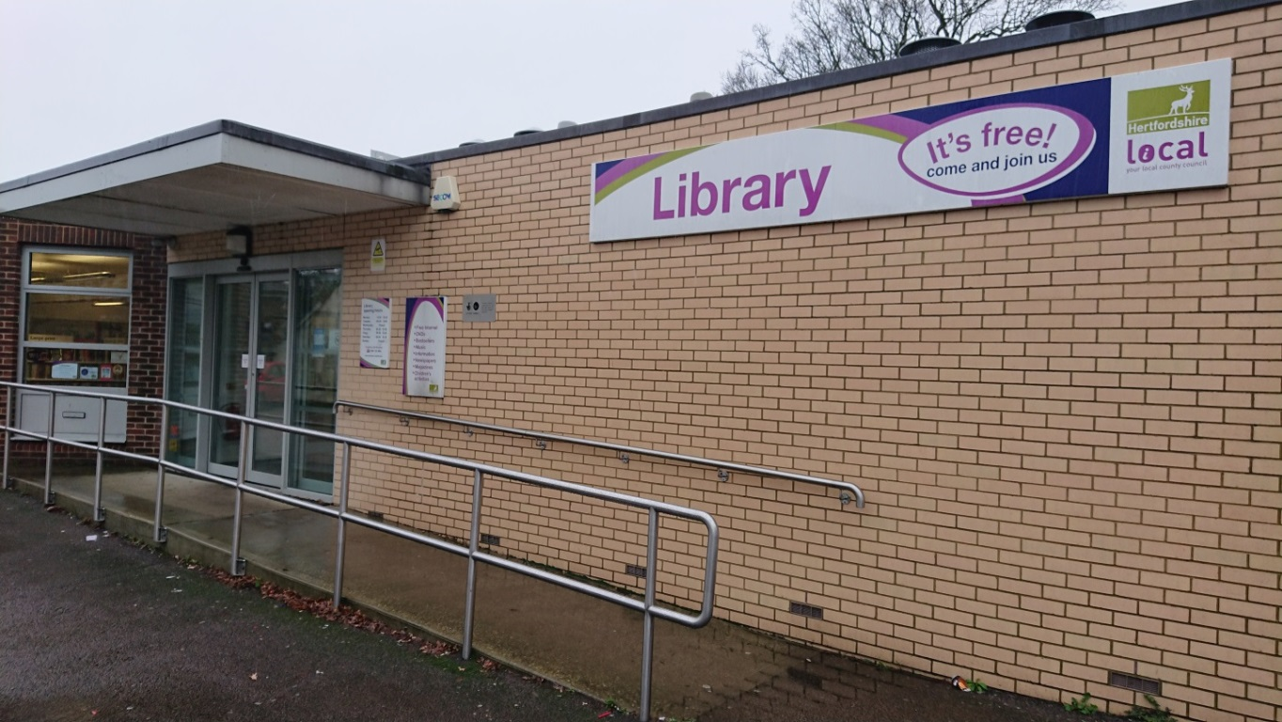

**Oxhey Library, Bridlington Road, South Oxhey, WD19 7AG**

**Opening Hours:**

|  |  |  |  |
| --- | --- | --- | --- |
| Monday | 2.00pm | - | 6.00pm |
| Tuesday | 9.30am | - | 6.00pm |
| Wednesday | Closed |  |  |
| Thursday | 9.30am | - | 6.00pm |
| Friday | 9.30am | - | 6.00pm |
| Saturday | 9.30am | - | •1.00pm |
| Sunday | Closed |  |  |

This is a simple guide to help people visiting Oxhey Library for the first time, if you have any questions please ask the staff.

|  |  |
| --- | --- |
| outside view of a brick building. there is a ramp at the front for wheelchair access and a large sign on the wall saying library | This is Oxhey Library   |
| desk with a computer on and 2 chairs in front | This is the help desk please ask for help here.    You may have to wait if we are busy. |
| a woman holding her staff badge | Library staff are here to help. All library staff wear a badge like this.   |
| library cards front and back | This is a library card, you will get one when you become a library member.    You need a library card to borrow books and DVDs and to use the computers.  To get a library card, ask the staff at the help desk. |
| **headphones** | Sometimes we have noisy times in the library and you may wish to visit at a quieter time.    Or you can bring some ear defenders to wear. |
| pink self service kiosk | This is a kiosk. You can borrow and return books here.    Follow the instructions on the screen. Ask the library staff if you need help.  If it is busy you may need to queue. |
| large area with colourful carpet in the middle and bookshelves along the walls | This is the children’s area.   |
| shelves with books | There are lots of books you can borrow.   |
| shelves with magazines | There are magazines which you can borrow.   |
| toilet sign with stylised pictures of a woman, a man, a person changing a baby and a person in a wheelchair | There is a toilet in the library. If it is busy you may need to queue. |
| desks with computer screens, keyboard and a scanner | These are some of our computers which you can use.    Library members can use them for free for one hour a day.  If the computers are busy you may need to book. Ask the library staff if you need help. |
| large area with tables and chairs | This is the quiet study area.  There is free Wi-Fi in the library.   wifi logo  Ask staff for login details. |
| cid:e43681d1-e20f-4615-8f86-7795d43b3938@Hertfordshire.gov.uk | When you are ready to leave the library, take the things that you want to borrow to the kiosk and follow the instructions on the screen.    Ask the library staff if you need help.  If it is busy you may need to queue. |
| cid:4c311b1f-8343-42b0-8ecf-9e181c4cca5d@Hertfordshire.gov.uk | You can take the things you have borrowed home. Print a receipt so you know when you need to bring them back to the library.    Remember to return or renew your items on time to avoid charges.  You can renew your items at the kiosk or:   * ask at the desk * online at [www.hertfordshire.gov.uk/libraries](http://www.hertfordshire.gov.uk/libraries) * Telephone: 0300 123 4049 * Textphone: 0300 123 4041 |
| cid:38b11f0d-3e1d-4975-99eb-d73f8a421c04@Hertfordshire.gov.uk | We hope you enjoyed the story.  If you need any extra help or information please ask a member of staff.     For more information on the library please visit our website:  [www.hertfordshire.gov.uk/oxheylibrary](https://www.hertfordshire.gov.uk/oxheylibrary)  Please come back soon. ☺ |