**Bushey Library Visual Story**

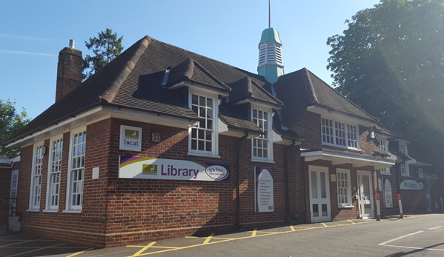

**Bushey Library, Sparrows Herne, Bushey, WD23 1FA**

**Opening Hours:**

|  |  |  |  |
| --- | --- | --- | --- |
| Monday | •1.00pm | - | 6.00pm |
| Tuesday | 10.00am | - | 6.00pm |
| Wednesday | •1.00pm | - | 6.00pm |
| Thursday  ***Self-service*** | 10.00am | - | 2.00pm |
| Friday | 10.00am | - | 6.00pm |
| Saturday | 10.00am | - | 5.00pm |
| Sunday | Closed |  |  |

This is a simple guide to help people visiting Bushey Library for the first time, if you have any questions please ask the staff.

|  |  |
| --- | --- |
| **outside view of a large brick building with a sign saying library** | This is Bushey library   |
| **a lady behind a desk with a computer. There is a chair in front of the desk and book shelves and a notice board in the background** | This is the help desk. Ask here if you need help or have any questions.    If it is busy you may need to queue. |
| a lady smiling showing her staff badge | Library staff are here to help. All library staff wear a badge like this.   |

|  |  |
| --- | --- |
| **headphones** | Sometimes we have noisy times in the library and you may wish to visit at a quieter time.    Or you can bring some ear defenders to wear. |

|  |  |
| --- | --- |
| **library cards front and back** | This is a library card, you will get one when you become a library member.    You need a library card to borrow books and use the computers.  To get a library card, ask the staff at the help desk. |
| **pink self service kiosk** | This is a kiosk. You can borrow and return books here.    Follow the instructions on the screen. Ask the library staff if you need help.  If it is busy you may need to queue. |
| **large room with a blue sofa facing 5 small plastic chairs wit a carpet in the middle and bookshelves in the background** | This is the children’s area.   |
| **shelves with books** | There are lots of books you can borrow.    If you cannot find a book you are looking for, you can ask the library staff to help. |

|  |  |
| --- | --- |
| shelves with magazines on display  shelves with audiobooks | You can also borrow magazines and books you can listen to on CD.   |
| toilet sign with stylised pictures of a woman, a man, a person changing a baby and a person in a wheelchair | There is a toilet in the library.    If it is busy you may need to queue. |
| long computer desk with 5 computer screens and keyboards and a scanner | These are the computers. Library members can use them for free for one hour a day.    If the computers are busy you may need to book. Ask the library staff if you need help. |
| woman sitting a a table using her laptop with book shelves in the background | This is the quiet study area. There is free Wi-Fi in the library.   wifi logo  Ask staff for login details.  Desks with power sockets are available.  You can charge your own device here. |
| close up of self service kiosk with books on it and a hand holding a library card | When you are ready to leave the library, take the things that you want to borrow to the kiosk and follow the instructions on the screen. Ask the library staff if you need help.    If it is busy you may need to queue. |
| hand taking a receipt from self service kiosk | You can take the things you have borrowed home. Print a receipt so you know when you need to bring them back to the library.  Remember to return or renew your items on time to avoid charges.  You can renew your items at the kiosk or:   * ask at the desk * online at [www.hertfordshire.gov.uk/libraries](http://www.hertfordshire.gov.uk/libraries) * Telephone: 0300 123 4049 * Textphone: 0300 123 4041 * With the library app – from App Store or Google Play |
| cid:38b11f0d-3e1d-4975-99eb-d73f8a421c04@Hertfordshire.gov.uk | We hope you enjoyed the story.  If you need any extra help or information please ask a member of staff.     For more information on the library please visit our website:  [www.hertfordshire.gov.uk/busheylibrary](https://www.hertfordshire.gov.uk/busheylibrary)  Please come back soon. ☺ |